1)Given an m x n grid and a ball at a starting cell, find the number of ways to move
the ball out of the grid boundary in exactly N steps.

def findPaths(m, n, N, startRow, startColumn):
dp = [[0] * n for _ in range(m)]
dp[startRow][startColumn] = 1

result = 0

for step in range(N):
new_dp = [[0] * n for _ in range(m)]

for i in range(m):
for j in range(n):
if dp[i][j] > 0:
# Up
if i == 0:
result += dp[i][j]
else:
new_dp[i - 1][j] += dp[i][j]

# Down
if i == m - 1:
result += dp[i][j]
else:
new_dp[i + 1][j] += dp[i][j]

# Left
if j == 0:
result += dp[i][j]
else:
new_dp[i][j - 1] += dp[i][j]

# Right
if j == n - 1:
result += dp[i][j]
else:
new_dp[i][j + 1] += dp[i][j]

dp = new_dp

return result

# Sample Input
m = int(input("Enter rows: "))
n = int(input("Enter columns: "))
N = int(input("Enter number of steps: "))
startRow = int(input("Enter starting row: "))
startColumn = int(input("Enter starting column: "))

print("Number of ways:", findPaths(m, n, N, startRow, startColumn))

output
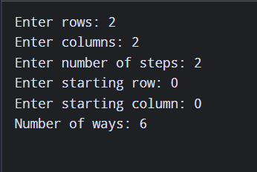

2)You are a professional robber planning to rob houses along a street. Each house
has a certain amount of money stashed. All houses at this place are arranged in a
circle. That means the first house is the neighbor of the last one. Meanwhile,
adjacent houses have security systems connected, and it will automatically
contact the police if two adjacent houses were broken into on the same night.

def rob(houses):
if len(houses) == 1:
return houses[0]

def rob_linear(arr):
prev = 0
curr = 0

for money in arr:
new_curr = max(curr, prev + money)
prev = curr
curr = new_curr

return curr

# Case 1: Exclude first house
case1 = rob_linear(houses[1:])

# Case 2: Exclude last house
case2 = rob_linear(houses[:-1])

return max(case1, case2)

# Sample Input
n = int(input("Enter number of houses: "))

houses = list(map(int, input("Enter money in each house: ").split()))

print("Maximum money robbed:", rob(houses))

Output

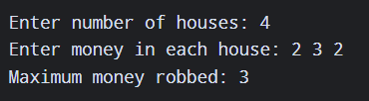

3)You are climbing a staircase. It takes n steps to reach the top. Each time you
can either climb 1 or 2 steps. In how many distinct ways can you climb to
the top?

def climb_stairs(n):
if n <= 2:
return n

a = 1
b = 2

for i in range(3, n + 1):
c = a + b
a = b
b = c

return b

# Sample Input
n = int(input("Enter number of steps: "))

print("Number of ways:", climb_stairs(n))

output
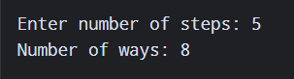

4)A robot is located at the top-left corner of a m×n grid .The robot can only
move either down or right at any point in time. The robot is trying to
reach the bottom-right corner of the grid. How many possible unique
paths are there?

def unique_paths(m, n):
dp = [[1] * n for _ in range(m)]

for i in range(1, m):
for j in range(1, n):
dp[i][j] = dp[i - 1][j] + dp[i][j - 1]

return dp[m - 1][n - 1]

# Sample Input
m = int(input("Enter number of rows: "))
n = int(input("Enter number of columns: "))

print("Number of unique paths:", unique_paths(m, n))

Output

